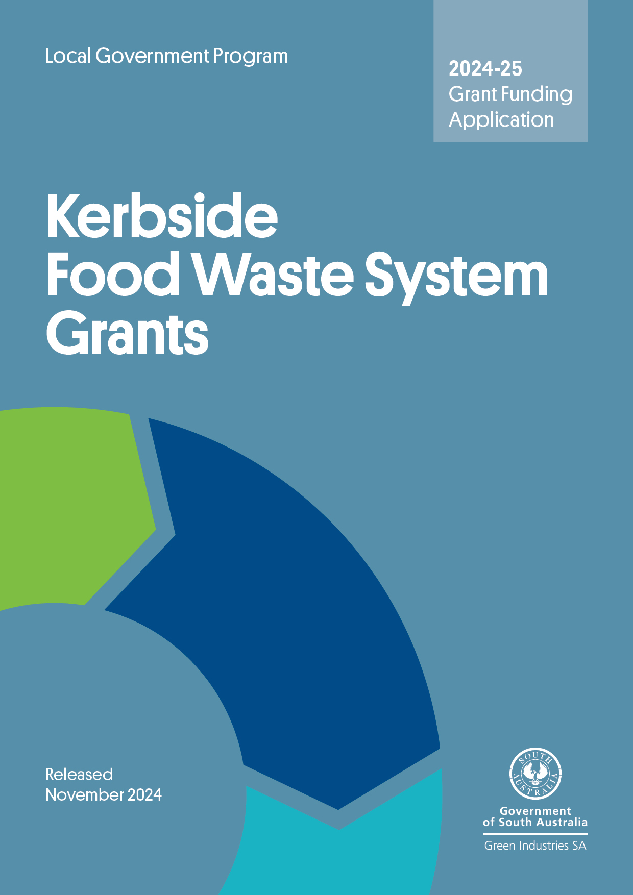

# 

**Application form**

**Program overview**

*Kerbside Food Waste System Grants* assist councils to implement sustainable and efficient food waste recycling systems for households and small business. It recognises that disposing food to landfill represents the loss of a potentially valuable resource and contributes to landfill greenhouse gas emissions, and that when food waste is blended with kerbside green organic material, it improves the quality and nutrient value of the processed compost.

**Submitting your application**

Applications will be accepted until **5 pm ACDT, 13 December 2024**

**Late or incomplete applications may not be accepted.**

Please email your completed application, including all supporting documents to:

justin.lang@sa.gov.au with the subject line **Kerbside Food Waste System Grants – application**. Emails should not exceed **10MB.**

**Checklist**

Before submitting your application, please check the application has:

* been signed by an authorised officer
* as much supporting information as possible, including detailed quotes for any goods
* quotes that must include supplier details including ABN and any GST component.

The application form in this document must be filled out completely and submitted by the Chief Executive (or delegated officer) of the council/subsidiary.

|  |
| --- |
| **Need assistance?**  Email [justin.lang@sa.gov.au](mailto:justin.lang@sa.gov.au) or telephone (08) 8429 8416 for more information.  Councils seeking assistance with area-wide distribution of green organics bins as well as food waste containers and compostable bin liners are encouraged to make contact. |

#### 1. Applicant details

|  |  |  |  |  |  |  |  |  |
| --- | --- | --- | --- | --- | --- | --- | --- | --- |
| Name of the Organisation | | | | | | | | |
|  | | | | | | | | |
| ABN of the Organisation | | | | | | | | |
|  | | | | | | | | |
| Is Your Organisation (Tick one): | | | | | | | | |
| The lead organisation of a consortium or partnership? | | | |  | | | The sole applicant? |  |
| If you are applying as the lead partner in this application, please give the names of the other organisations in the project. | | | | | | | | |
|  | | | | | | | | |
| Contact Details | | | | | | | | |
| Name of person dealing with this application | | | | | | | | |
| Title: | First name: | | Last Name: | | | | | |
| Job title of person named above | | | | | | | | |
|  | | | | | | | | |
| **Tel No:** | | **Mobile:** | | | | **Fax:** | | |
| E-mail: | | | | | | | | |
| Postal address for correspondence: | | | | | | | | |
| **Address 1:** | | | | | | | | |
| **Address 2:** | | | | | | | | |
| **Town/Suburb:** | | | | | **Postcode:** | | | |

#### 2. Details of kerbside waste and green organics services

|  |  |  |
| --- | --- | --- |
| Residual waste service | 140 L Capacity | Other _______ |
| Residual waste collection frequency  Receival facility: | weekly | fortnightly |
| Green organics collection frequency  Receival and processing facility: | Fortnightly | Weekly |

#### 3. Details of proposed food organics system

|  |  |  |
| --- | --- | --- |
| Container manufacturer (supplier):  Contact details for supplier: | Name:  Address:  Phone: | |
| Container type: | Ventilated (requiring compostable liner bags) | Non-ventilated (low priority in this round) |
| Number of services to be provided: | , Commercial premises  (round to nearest 50) | , Households (round to nearest 100) |
| Estimated cost per container: | $ | Capacity: Litres |
| Was this price sought through a competitive tender process? | Yes, please provide details below of tender | No, please detail selection process to be undertaken |
| Tender / selection process: | | |
| What is council’s current disposal cost/tonne for residual waste? $ | | |
| What is council’s current processing cost/tonne for organics? $ | | |

#### 4. Proposed budget (itemise all capital expenditure items)

|  |  |  |  |  |  |
| --- | --- | --- | --- | --- | --- |
| Expenditure Item | Anticipated Order Date | Funding Sought  (no more than 50%) | Applicant Contribution | Other Funding Sources (please specify below) | Total Cost |
| Description | 20.9.23 | $ | $ | $ | $ |
| Containers |  |  |  |  |  |
| Compostable liner bags (if required) |  |  | N/A |  |  |
| Education material – brochure |  |  |  |  |  |
| Education material – stickers/prompts |  |  |  |  |  |
| Distribution |  |  |  |  |  |
| Other (please specify) |  |  |  |  |  |
| **Totals:** |  | **$** | **$** | **$** | **$** |
| GISA funding as % of total funding: |  |  | | | |
| **Other Funding Sources:** | | | | | |

**5. Project summary**

|  |
| --- |
| Please give a short description of the project (including method of providing bags and containers where required). |
|  |

#### 6. Council approval and budget allocations

|  |  |  |
| --- | --- | --- |
| If your application is approved, you will need to provide details of council resolutions and reports within 3 months of the signing of contracts, and before grant funds are released. If already obtained, please attach a copy. | | |
| Has Council resolved to introduce a food waste system?  If no, when is the resolution likely to be provided? (please detail below) | Yes | No |
| If yes, have you included details of the resolution and report? | Yes | No |

#### 7 Implementation timeline

|  |  |
| --- | --- |
| Action | Estimated Date (mm-yyyy) |
| Order containers |  |
| Design of education material (contact GISA for customised *Which Bin* templates) |  |
| Initial communication to residents (e.g. Council newsletter) |  |
| Printing education materials |  |
| Shipping (delivery to central location) |  |
| Assembly and distribution of containers |  |
| Start collections |  |

#### 8. Contracts for collection and processing

|  |  |  |
| --- | --- | --- |
|  | | |
| Name of collection contractor and EPA licence number:  Collection contractor EPA license number: |  | |
| Contract in place for collection of organics:  Yes/  No | Yes | Expiry date: |
| Name of licenced organics processor and EPA licence number:  Organics processor EPA license number: |  | |
| Contract in place to accept organics?  Yes/  No | Yes | Expiry date: |
| End markets where composted material is sent: |  |  |

#### 9. Communication and consultation

|  |  |  |
| --- | --- | --- |
| Has a communications plan been prepared? | Yes, (please include/attach) | No |
| Please detail what community consultation has/will occur: | | |
|  | | |
| Please indicate below what efforts Council will be putting into education **for the term of the Agreement with GISA.** | | |
| Regular features in Council newsletters | Composting workshops | |
| Web-based waste reduction information | Regular ads in local papers | |
| Community education brochure | Social media | |
| Tours of composting facilities | Other (please specify) | |
| *Which Bin* resources requested (brochure, rates insert, DL fridge magnet, social media tiles) | | |

#### 10. Contact persons

|  |
| --- |
| Demonstration of technical expertise and capacity to manage project (1-2 staff) (100 characters except Relevant Experience – 250 characters) |
| **Name:** |
| **Position:** |
| **Role in this project:** |
| **Relevant experience/expertise:** |
| **Name:** |
| **Position:** |
| **Role in this project:** |
| **Relevant experience/expertise:** |

#### 11. Declaration

I declare that the information on this application form and the supporting information enclosed with it are accurate to the best of my knowledge.

**Declaration**

· I/we have read and understood the Guidelines and obtained clarification where needed.

• I/we declare that the information provided in this application including attachments is true and correct and discloses all required and relevant details.

• I/we understand that if information supplied as part of the application is false or misleading in a material particular, the application will not be considered OR, if the grant is made and it is discovered that information supplied was false or misleading in a material particular, the grant will be revoked and funds, plus interest, must be repaid. An assessment regarding possible fraud will also be undertaken and appropriate legal action initiated if warranted.

• I/we authorise Green Industries SA to seek any additional relevant information required to process this application, and I/we hereby request and authorise any parties to supply such information as requested.

• I/we understand that if the project is approved for funding, information about the project may be publicised by Green Industries SA or provided as required or permitted by law.

• If the project is approved for funding, I/we will obtain all necessary and appropriate clearances from the relevant Commonwealth, state or local governments (if applicable) before executing the grant agreement and undertake to manage the proposed project in accordance with relevant laws and regulations.

• If I/we accept an offer of funding, then I/we accept (jointly and severally in the case of a group application) responsibility for administering grant funds and liability in the event grant funds are to be repaid.

|  |  |  |
| --- | --- | --- |
| Signed |  |  |
| Name |  |  |
| Position |  |  |
| Date |  |  |

The Chief Executive Officer of your authority should sign the application form. It should not be signed by the contact person/s unless they are one and the same.